Technical Specifications of Heel Strap

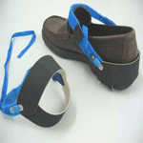

Designed for use in electronic shop floor with conductive heel and elastic fastener for use on any footwear worn by the operator. Provides grounding path for dissipation of Static Charges

SPECIFICATION:

Surface Resistivity

Conductive Rubber : 10⁴ –10⁶ ohm/sq
Conductive Strip : 10⁴ –10⁶ ohm/sq

Surface to ground Resistance : <50 Meg ohm
Discrete Resistance : Built-in 1 meg ohm, ¼ watt.

